How to IP in Windows 11

Important Note
The following information is for Windows 11—steps will differ if you are using a different operating system.

Understand how Network Information is Configured on a Windows Computer. Many times, connectivity issues are attributed to wrong network settings. In troubleshooting connectivity issues, several tools are available to quickly determine the network configuration for any Windows computer.

Step 1: Examine network properties settings.
One method that may be useful in determining the network interface IP properties is to examine the pod host computer’s Network Properties settings. To access this window:
- Click Start > Run. In the dialog box type ncpa.cpl and press Enter.
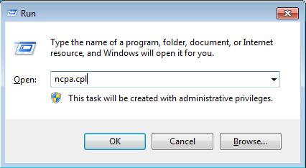
- This will bring up the Network Connections Control Panel listing all the network devices on your computer. Right-click Realtek ( your Ethernet NIC) and choose Properties.

- On the Networking tab, scroll down the list of items in the pane, select Internet Protocol Version 4 (TCP/IPv4), and click the Properties button. A window similar to the one in Figure 1 will be displayed.
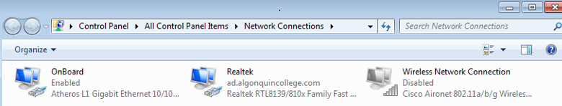

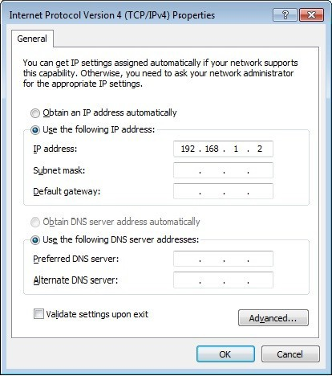

Figure 1. Network Interface with Static IP Address

Dynamic IP address:
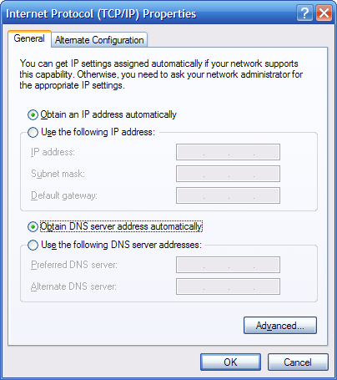
However, a dynamic IP address may be configured, as shown in Figure 2. In this case, the Network Properties settings window is not very useful for determining IP address information.

Figure 2. Network Interface with Dynamic IP Address

A more consistently reliable method for determining network settings on a Windows computer is to use the ipconfig command:
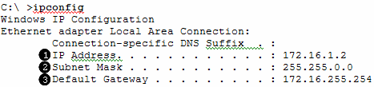
❶ IP address for this pod host computer
❷ Subnet mask
❸ Default gateway address

Several options are available with the ipconfig command, accessible with the command.

ipconfig /?
To show the most information about the network connections, use the command ipconfig /all.
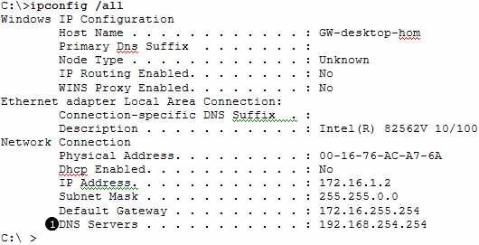
Domain name server IP address

Applying an IP address to your computer (Static IP)
Follow the step-by-step instructions below.
- Click Start > Run. In the dialog box type ncpa.cpl and press Enter. The Network Connections Control panel window should appear, with icons showing the different network connections.
- Right-click on the network connection you wish to configure (normally Local Area Connection) (your Ethernet card) and click Properties.
- Select the Internet Protocol Version 4 (TCP/IPv4) item and then click the Properties button.
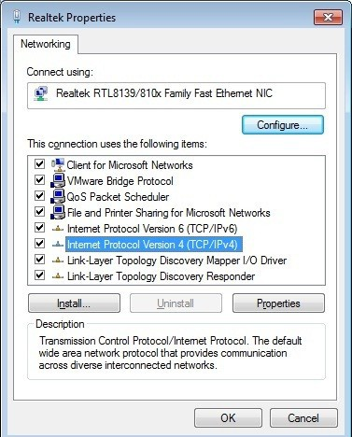

- On the General tab of the Internet Protocol (TCP/IP) Properties window, select the Use the following IP address option.
- In the IP address box, enter the IP address – this will depend on the network you are on.
- Press the tab key and the Subnet mask is automatically entered. The subnet address – again, this will depend on your network settings. If this address is not automatically entered, enter this address manually.
- Click OK.
- Give your gateway IP if you have one.
- Close the Local Area Connection Properties window.

Verify network connectivity.
- On your computer, click Start, and then click Run.
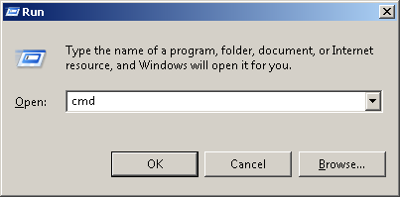
- Type cmd in the Open box and then click OK.
The DOS command (cmd.exe) window will appear. You can enter DOS commands using this
window. For the purposes of this lab, basic network commands will be entered to allow you to test your computer connections.
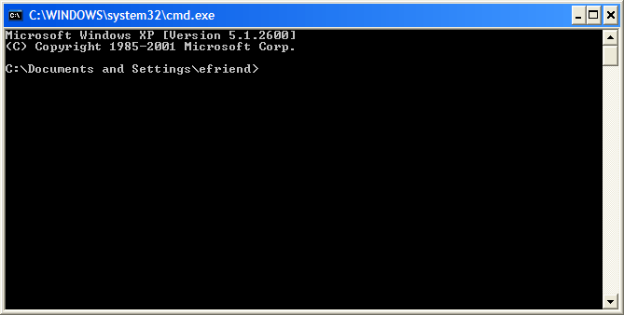
- Use the ping command to test whether a host is reachable across the network or not.
- You should usually ping:
  - ping <you_own_ip_address>
  - ping <your_gateway>
  - ping <some_other_ip>

How Wireshark works
Using Wireshark™ to View Protocol Data Units (PDU)

Background
Wireshark is a software protocol analyzer, or "packet sniffer" application, used for network troubleshooting, analysis, software and protocol development, and education. Before June 2006, Wireshark was known as Ethereal.
A packet sniffer (also known as a network analyzer or protocol analyzer) is computer software that can intercept and log data traffic passing over a data network. As data streams travel back and forth over the network, the sniffer "captures" each protocol data unit (PDU) and can decode and analyze its content according to the appropriate RFC or other specifications.
Wireshark is programmed to recognize the structure of different network protocols. This enables it to display the encapsulation and individual fields of a PDU and interpret their meaning.
For information and to download the program go to - http://www.Wireshark.org

Scenario
To capture PDUs the computer on which Wireshark is installed must have a working connection to the network and Wireshark must be running before any data can be captured.
When Wireshark is launched, the screen below is displayed.

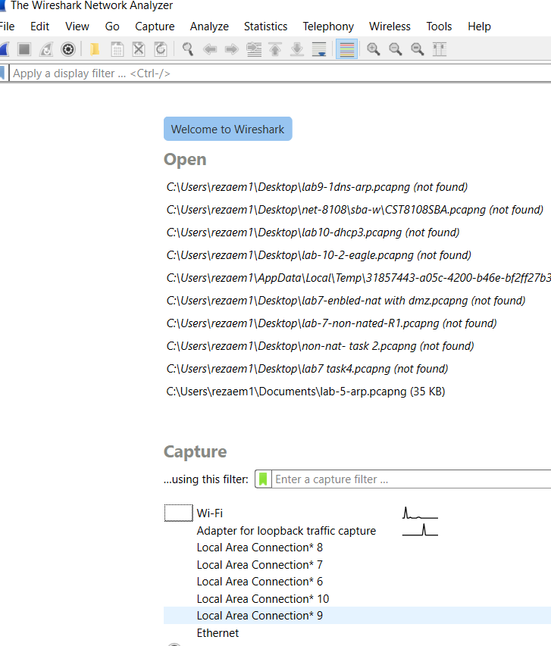

To start data capture it is first necessary to select which interface (or interfaces) you want to capture from. There are several ways to do this, but the easiest way is to find the “Start” button. Under the button click to select the interface you want to use then click start

Typically, for a computer, this will be the connected Ethernet Adapter.

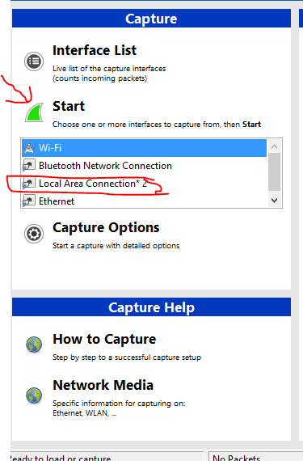
Setting Wireshark to capture packets in promiscuous mode.
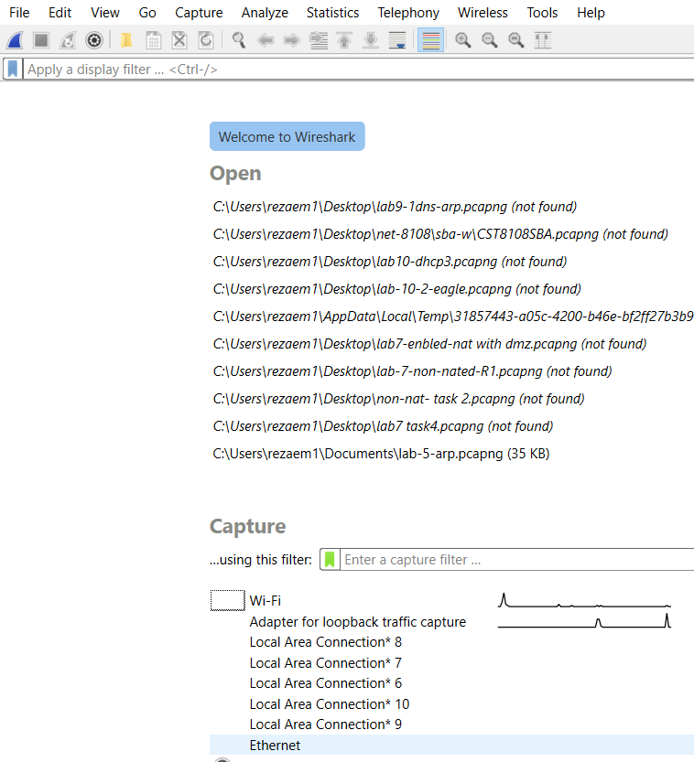

Old Wireshark New Wireshark

Clicking the Capture, “Options” button will allow you to set up options for the capture. Ensure “Use promiscuous mode on all interfaces” is checked. If this feature is NOT checked, only PDUs destined for this computer will be captured. If this feature is checked, all PDUs destined for this computer AND all those detected by the computer NIC on the same network segment (i.e., those that "pass by" the NIC but are not destined for the computer) are captured.
Note: The capturing of these other PDUs depends on the intermediary device connecting the end device computers on this network. As you use different intermediary devices (hubs, switches, routers) throughout these courses, you will experience different Wireshark results.

Setting Wireshark for network name resolution
This option allows you to control whether Wireshark translates network addresses found in PDUs into names. Although this is a useful feature, the name resolution process may add extra PDUs to your captured data perhaps distorting the analysis.
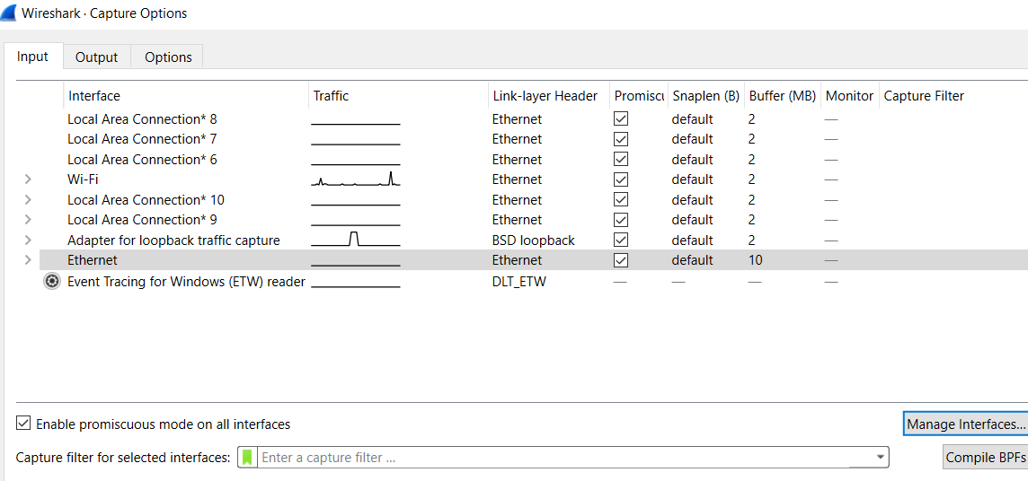

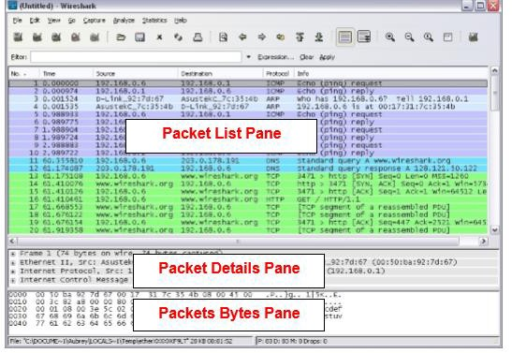
There are also several other capture filtering and process settings available. Clicking on the Start button starts the data capture process and the main screen is displayed. The examples below show the capture of a ping process and then accessing a web page.
When the Stop button is clicked, the capture process is terminated.
This main display window of Wireshark has three panes.

The PDU (or Packet) List Pane at the top of the diagram displays a summary of each packet captured. By clicking on packets in this pane, you control what is displayed in the other two panes.

The PDU (or Packet) Details Pane in the middle of the diagram displays the packet selected in the Packet List Pane in more detail.
The PDU (or Packet) Bytes Pane at the bottom of the diagram displays the actual data (in hexadecimal form representing the actual binary) from the packet selected in the Packet List Pane, and highlights the field selected in the Packet Details Pane.
Each line in the Packet List corresponds to one PDU or packet of the captured data. If you select a line in this pane, more details will be displayed in the "Packet Details" and "Packet Bytes" panes. The example above shows the PDUs captured when the ping utility was used and http://www.Wireshark.org was accessed. Packet number 1 is selected in this pane.

The Packet Details pane shows the current packet (selected in the "Packet List" pane) in a more detailed form. This page shows the protocols and protocol fields of the selected packet. The protocols and fields of the packet are displayed using a tree, which can be expanded and collapsed.
The Packet Bytes pane shows the data of the current packet (selected in the "Packet List" pane) in what is known as "hex dump" style. In this lab, this pane will not be examined in detail. However, when more in-depth analysis is required, this displayed information is useful for examining the binary values and content of PDUs.
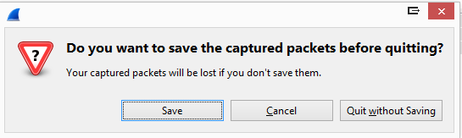
The information captured for the data PDUs can be saved in a file. When closing a data capture screen or exiting Wireshark you are prompted to save the captured PDUs.

Clicking on Continue without Saving closes the file or exits Wireshark without saving the displayed captured data.

Cables

Learning Objectives
Upon completion of this lab, you will be able to:
□ Correctly identify cables for use in the network.

Cables and more Cables
At the Physical layer (Layer 1) of the OSI model, end devices must be connected by media (cables). The type of media required depends on the type of device being connected. In the lab, you'll find three different types of cables:

1-Straight-through Cables:
Straight-through cable has connectors in each end that are terminated the same in accordance with either the T568A or T568B standards.

Use a straight-through cable for the following connections:
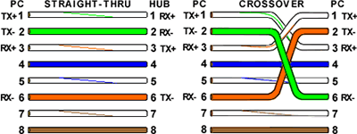
- Switch to router Ethernet port
- Computer to switch.
- Computer to hub

2-Crossover cable:
Directly connects two network devices of the same type over Ethernet. In T111 all the crossover cables are orange or yellow.

Use a crossover cable for the following connections:
- Switch to Switch
- Switch to hub
- Hub to hub
- Router to router Ethernet port
- Router to PC
- Router to server

3-Console Cables: (Roll over cable)
Connects a computer to a Cisco device via the console port. Our rollover cables have a DB9 connector at one end and a RJ45 connector at the other end.

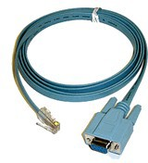
Use a console cable for the following connections:
- Computer to a switch console port
- Computer to a router console port

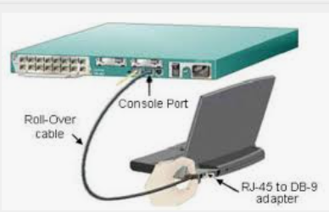
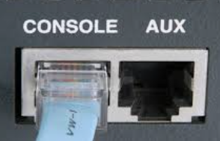

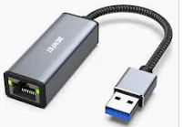

- RJ45 adapter to USB cable. (for laptops without RJ45 port)
Why are we using a crossover cable between the Router and the PC or server?
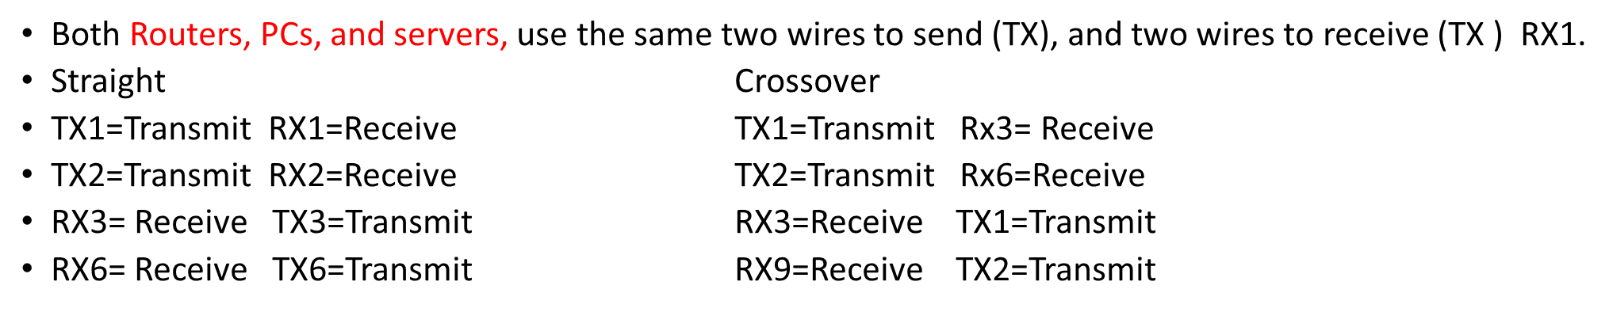
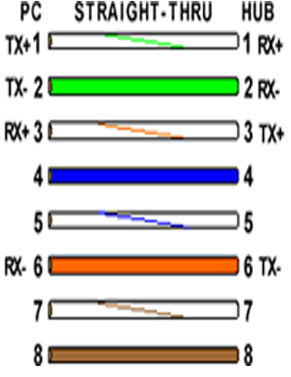
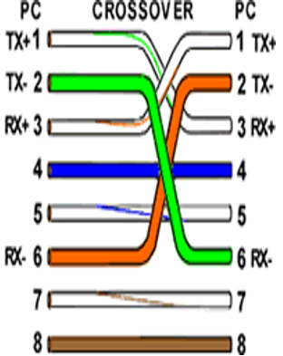
Linksys E2500

